Comwell Bygholm Parc
4 stars.
Enter this magnificent mansion dating from 1775 and discover an exceptional hotel. Former residence of noble families and landowners, it has been completely renovated in an elegant Scandinavian style. It offers large, bright rooms, a charming restaurant serving seasonal dishes, a modern bar and stunning views of Bygholm Park.
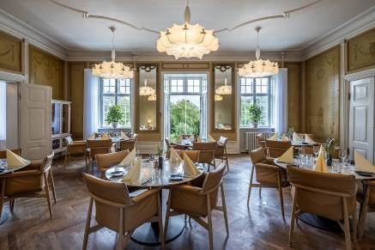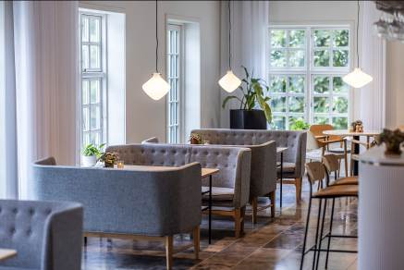The hotel is located in a green setting, near Horsens. It is therefore easily accessible. Upon your arrival, the friendly staff will be delighted to welcome you for a few days of relaxation.
