Comwell Køge Strand
4 stars.
The Comwell Køge Strand is a modern beach hotel overlooking Køge Bay. You can enjoy a relaxing atmosphere on a large terrace, in the heart of beautiful nature and a vast sandy beach. Inside you will find a newly renovated bar and the cozy restaurant, in bright rooms overlooking the sea.
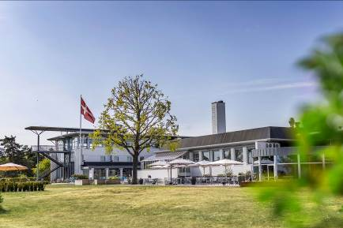The hotel is the ideal retreat for those visiting the historic medieval town of Køge and Copenhagen, located just 45 km away.
